**Goals of Data Analysis:**

1. ***Investment type analysis-*** *comparing the typical investments:*
   1. *Amount in ventures*
   2. *Seed*
   3. *Angel*
   4. *Private equity etc*

Solution –

**Angel** or seed investors participate in businesses that are so early-stage they may be pre-revenue with few to no customers at all.

Angel investors who invest collectively in small startups or entrepreneurs.

**Private Equity**: It is a less risky investment because the company is more firmly established, and the rounds are typically upwards of $50M.

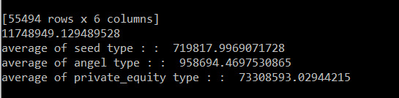

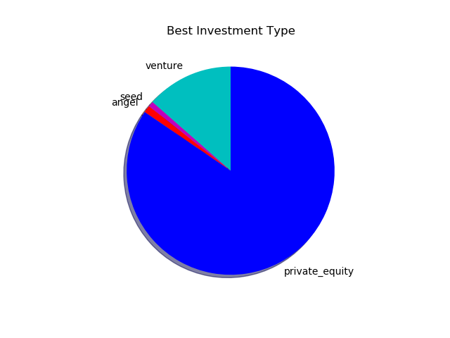

1. ***Country analysis-*** *countries most heavily invested in the past*

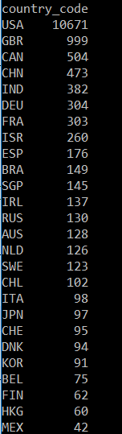

1. ***Sector analysis****- understanding the distribution of investments across the eight main sectors*

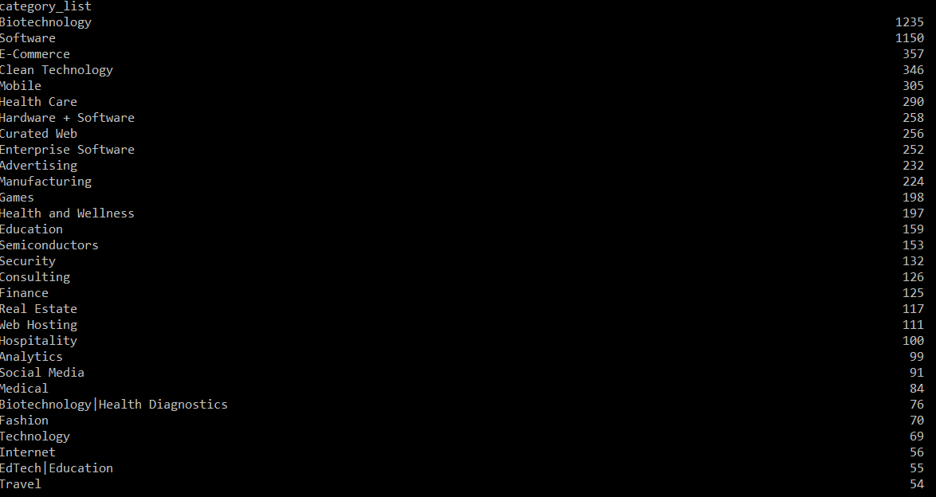

**Table 1.1: Understand the Data Set**

|  |  |
| --- | --- |
| How many **unique companies** are present in **rounds2**? | 425 |
| How many**unique companies** are present in **companies**? | 420 |
| In the **companies** data frame, which column can be used as the unique key for each company? Write the **name of the column**. | name |
| Are there any companies in the rounds2 file which are not present in companies? Answer yes or no: **Y/N** |  |
| Merge the two data frames so that all variables (columns) in the **companies**frame are added to the **rounds2** data frame. Name the merged frame **master_frame**. How many observations are present in master_frame? |  |

Considering that Spark Funds wants to invest between **5 to 15 million USD** per investment round, which investment type is the most suitable for it? Identify the investment type and, for further analysis, filter the data so it only contains the chosen investment type.

Great! You have crossed two checkpoints. There are four checkpoints left now.

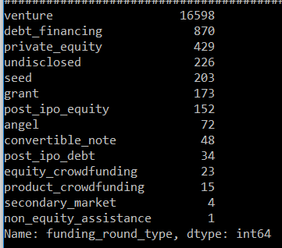

Table 3.1:Analysing the Top 3 English-Speaking Countries

|  |  |
| --- | --- |
| 1. Top English-speaking country | USA |
| 2. Second English-speaking country | INDIA |
| 3. Third English-speaking country | CANADA |